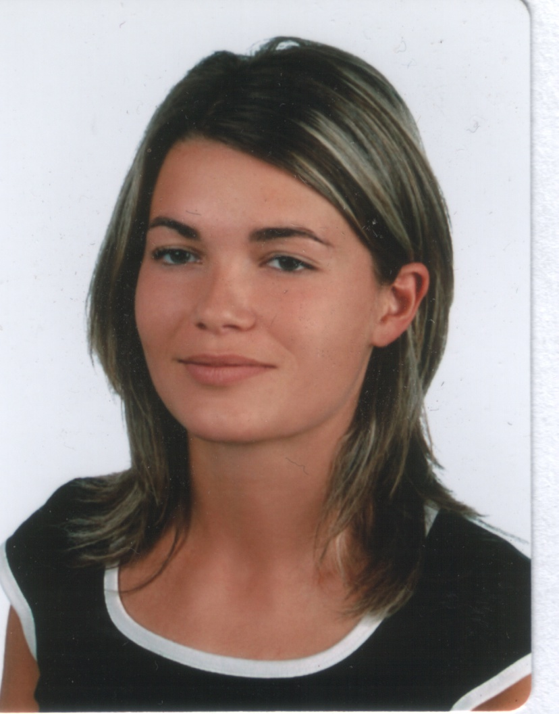
SAMPLE CV

home address
City, postal code country
Phone 00+countrycode+phone number
Fax 00+countrycode+fax number
E-mail

Student Name Insert Photo Here
Objective To obtain a placement which will allow me to enhance my skills and knowledge of the food & beverage industry, learn general business practices and procedures via practical training in preparation for my chosen career path

Expected Start Date: September 15, 2007
Term of Placement: 18-months

Work experience:
Oct ‘05-Present Dani’s Bar & Grille Rotterdam

Part-time Grille Room Captain, wait staff and bartender
- Responsible for reservations, meet, greet and seat customers, handle customer complaints and compliments
- Worked with Manager to plan and orchestrate customer banquets from initial contact to clean-up after the event
- Casual and formal dining service
- Filled in as bartender when required.
- Responsible for taking monthly liquor inventory, assist with monthly food inventory
- Assist Manager with supplies, linen and furniture orders as needed

June ‘05-Sept ’05 Hilltop Country Club Portland, Oregon

Wait staff
- Responsible for daily breakfast set-up and service
- Halfway House and golf course station service on Monday golf outing events
- Dinner and banquet set-up, and service at all club functions and events
- Worked with dining room manager to prepare staff schedules and train incoming staff

Oct ‘03-June ‘05 Dani’s Bar & Grille Rotterdam

Part-time Grille Room Captain, wait staff and bartender
- Responsible for reservations, meet, greet and seat customers, handle customer complaints and compliments
- Worked with Manager to plan and orchestrate customer banquets from initial contact to clean-up after the event
- Casual and formal dining service
- Filled in as bartender when required.
- Responsible for taking monthly liquor inventory

Jan ‘02-Oct ‘03 Dani’s Bar & Grille Rotterdam

Part-time, Wait staff
- Casual and formal dining service

Education:
2004-Present Metropolitan University [ City, State ]

Event Management Degree – Related Courses
- Food & Beverage/Catering
- Event Management
- International Tourism Management

Languages: English, Italian, French

References: [ Click here and enter information. ]

